Annual Goodwill Highlights:
- Placed in employment:
More than 288,000
- Earned high school diploma
or equivalent: 6,220
- Earned post-secondary credential: 16,906
- Personal and family support services provided:
More than 8.8 million
  - Financial education class sessions: More than 31,300
  - One-on-one financial coaching sessions:
More than 42,800
  - Federal Earned Income Tax Credits (EITCs) claimed: 7,425
- Total number of donors (includes repeat donations):
105 million
- Total number of stores, including outlet and retail:
More than 3,300

Every 25 seconds of every business day, a person served by Goodwill earns a good job.
Goodwill has helped people find jobs since 1902. Its network of 162 independent, community-based organizations provides employment placement and job training, along with services such as career counseling, mentoring, financial education, child care and transportation.
Goodwill helps people with disabilities and people who are underrepresented; veterans and military families; youth and young adults, including youth who are at risk and opportunity youth; older job seekers; people reintegrating into society; and others facing challenges to finding employment.
Goodwill organizations change lives by training people who are unemployed or underemployed for careers in fields such as information technology, health care, automotive services, construction, hospitality, manufacturing, retail and more.
At Goodwill, we believe that work creates the economic energy that builds strong families and communities. Work helps build self-confidence, friendships and independence.
Everyone deserves a chance to have those things in life.
Goodwill provides that chance.

About Goodwill®

how we operate

More than 87 percent of collective revenue from the sale of donated goods at Goodwill organizations support and grow their education and career services and other critical community-based programs.

Goodwill organizations support mission services through the sale of donated goods and household items at more than 3,300 Goodwill stores and online through shopgoodwill.com®, the first nonprofit internet auction site, and other online marketplaces, as well as through contract services, private and public grants, and individual giving.
Community-based Goodwill organizations also create jobs and build revenue by contracting with businesses and government to provide a wide range of commercial services, including janitorial, manufacturing, warehousing and distribution, packaging, assembly,
food preparation, document management, grounds keeping and administrative services.
General Electric, General Motors, SC Johnson, Whirlpool, Cintas, the General Services Administration, the Internal Revenue Service, and the U.S. Army, Air Force, Navy, and Marines are among those that have tapped into Goodwill services.
To learn more, visit goodwill.org/whygoodwill.

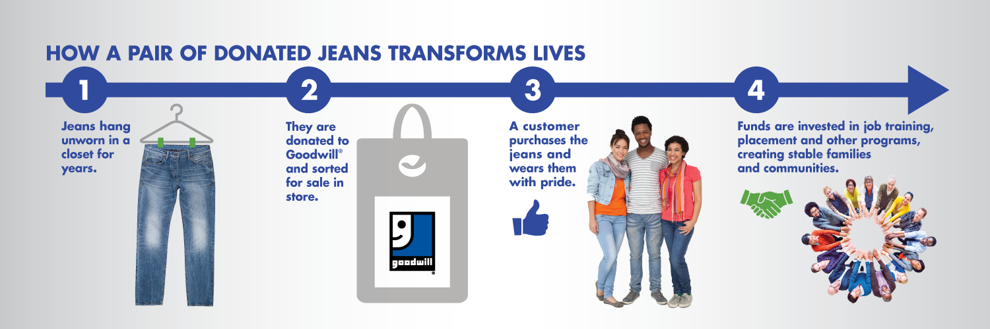

Every minute, 74 people access Goodwill opportunities to advance their careers.

www.goodwill.org | 1-800-GOODWILL | Facebook, Twitter, Instagram, YouTube, Pinterest: GoodwillIntl

