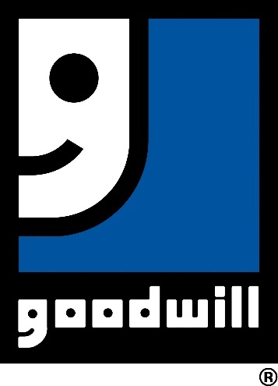

Goodwill XR/VR

**Desktop Setup & Installation Guide**

**March 2021**

# **Desktop OVERCOME Installation**

## **Pre-requisites**

Processor (CPU): Intel Core i5 (sixth generation or newer) or equivalent

Operating System: Microsoft Windows 10

Memory: 8 GB RAM

Storage: 2 GB internal storage drive

Monitor/Display: 720p or better.

Network: High speed internet 5Mbps or more

Other: Microphone

## **Installation**

1. Download the application from the Goodwill OVERCOME site by navigating to the site linked below, scrolling to the downloads section, and selecting the “OVERCOME Desktop Application Download” tile. Once downloaded, store the .zip file it in a convenient location.

**Goodwill OVERCOME Site**: <https://www.goodwill.org/overcome/>

1. Check in your Downloads folder to see the file: 
2. Right Click on the folder and select “Extract All”
3. Open the folder that is titled: Goodwill_oVeRcome
4. Open the application titled:

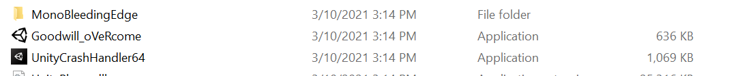

## **Troubleshooting**

### Microphone Selection

The experience relies heavily on voice recognition. One problem you might encounter is your voice not being recognized. Check that you microphone is plugged in and setup correctly. See: <https://support.microsoft.com/en-us/windows/how-to-set-up-and-test-microphones-in-windows-10-ba9a4aab-35d1-12ee-5835-cccac7ee87a4>

### Application Feels Slow or Choppy

If the experience feels choppy and or the video has delay loading, make sure the computer running the application meets the hardware requirements, above.

If the application still is performing slow or choppily, consider changing your monitor resolution to a smaller setting. See: <https://support.microsoft.com/en-us/windows/change-desktop-icon-size-or-screen-resolution-c6626736-5bb0-e094-7f03-49c828ff5da3>

### Misc.

Any corporate security, anti-virus, or MDM may delay the opening of the application

### Zip file wont open properly

The zip file may need to be unblocked before decompressing it in order to run the executable properly.

1. First right click on the folder “Build.zip” and select “Properties”

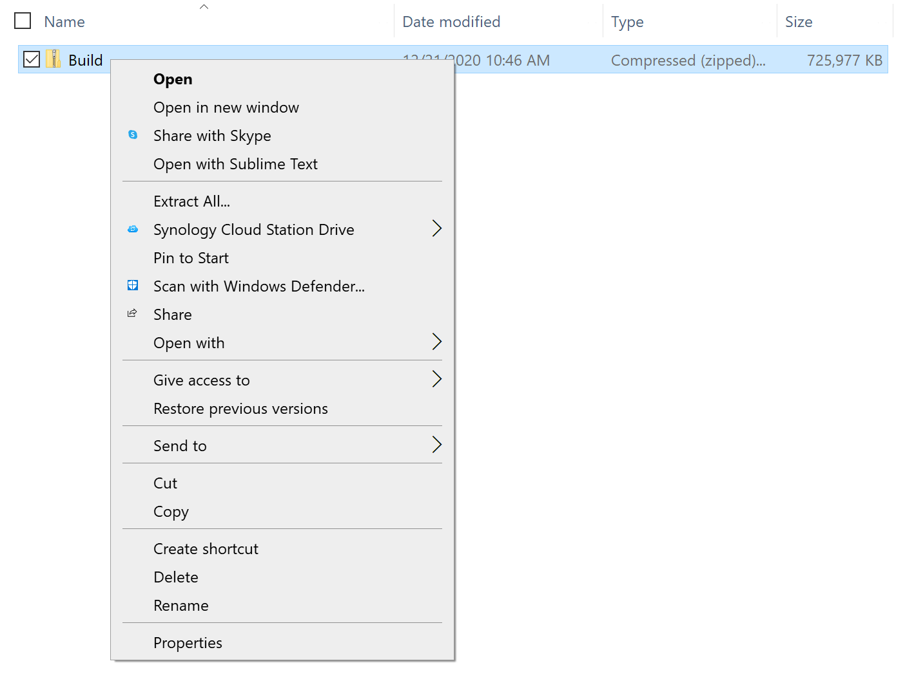

1. The properties dialogue window open, tick the Unblock radio button then press “Apply” and close the window.

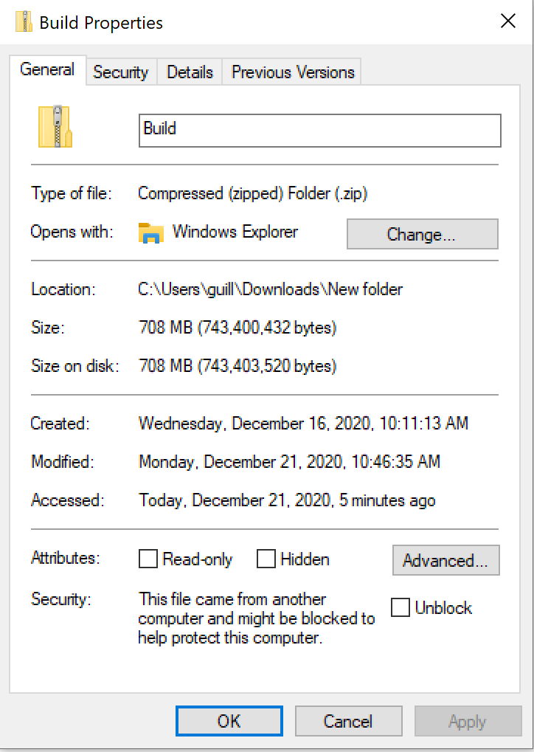 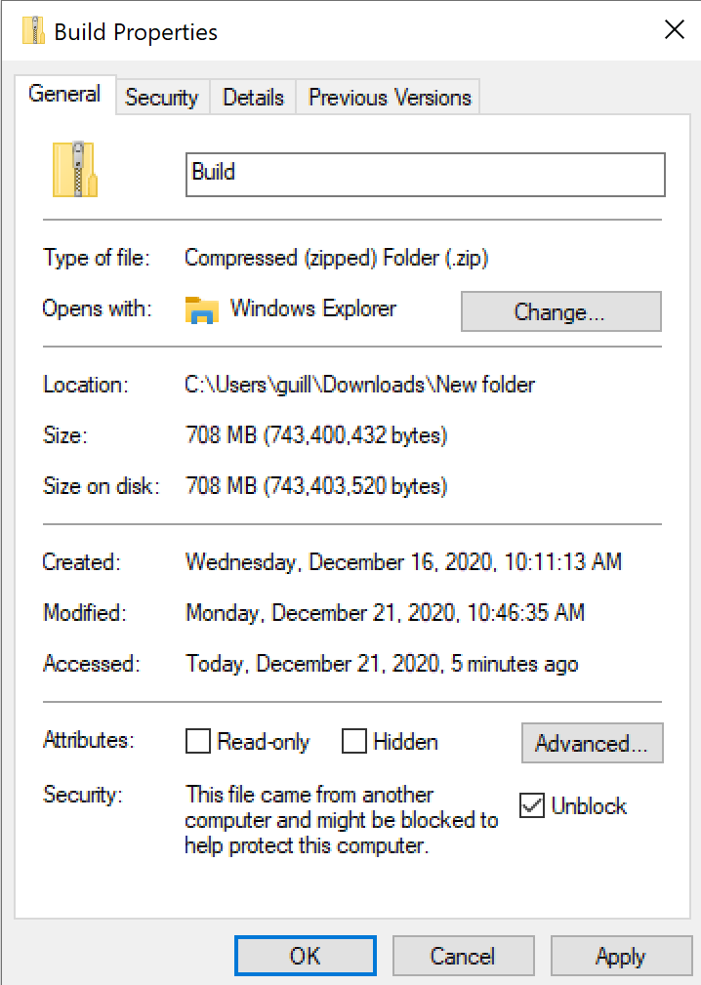 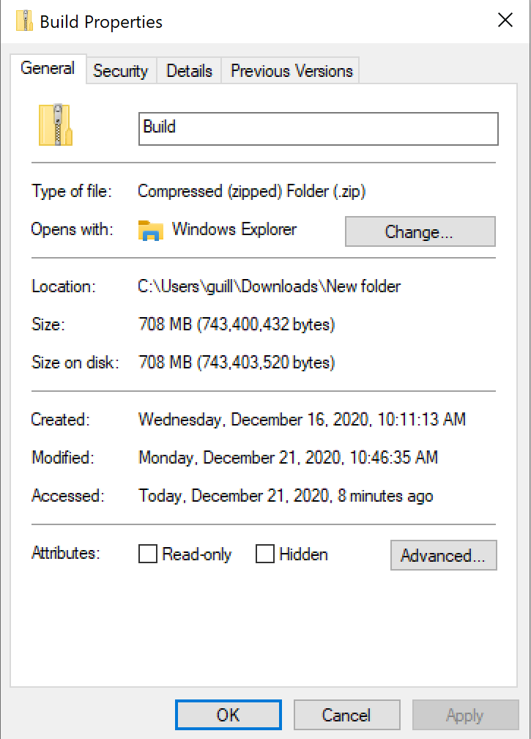

1. The application folder is compressed. Windows has a built-in decompression application. Right click on the “Build.zip” folder and select “Extract All”.

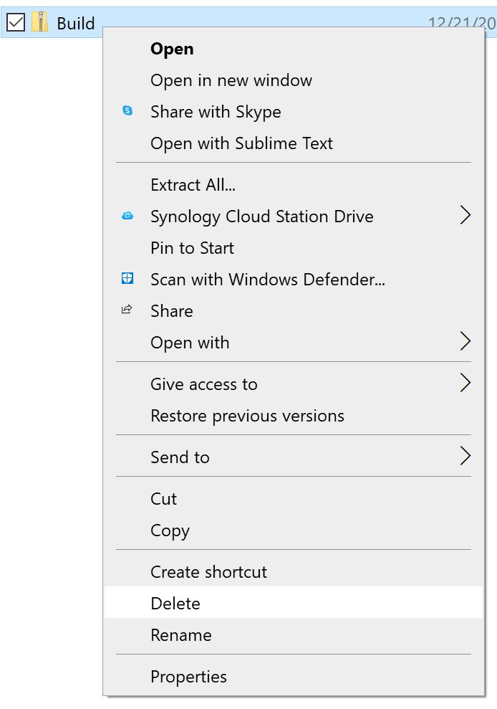

1. Once the application is de-compressed select the application “Standalone.exe” within the folders “Build>Standalone64”